Reseña del museo: Franz Mayer.
  - Sara Inés Martínez Espinosa.
Materia: Inglés.
Maestra: Claudia Flores Lobatón.

The Saturday I went to the museum Franz Mayer is a very beautiful please because is a colonial arquitect and in the center of the museum had a very big Court.
In the second floor was the exposition of “the 4° binal de ceramica” in this exposition you can see deferens sculptures like cups, some plates with a very beautiful decoration.
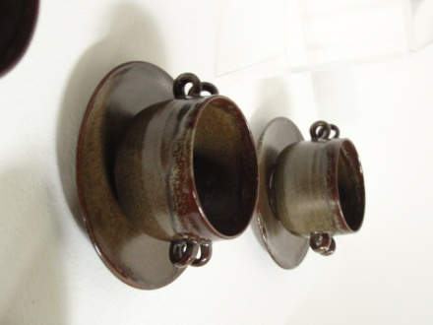
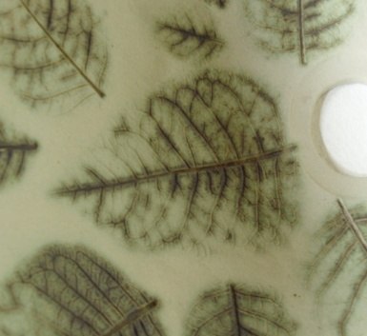
All so in this exposition have some instruments like flutes but in form of bears and docks.
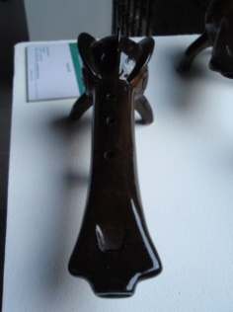

After this exposition I saw ad other a bout the 50 year of the history of the Barbies in this exposition you can saw that the barbies was a very important fact because de barbies was the first doll and represent the woman in different aspect of the life.
There was a lot of Barbies bout the most important was the first babie of color because after that you can buy barbies blond, brown breads and black.

